1. How many ConfigMaps exist in the environment?

kubectl get configmaps --all-namespaces

1. Create a new ConfigMap Use the spec given below.

ConfigName Name: webapp-config-map

Data: APP_COLOR=darkblue

kubectl create configmap webapp-config-map --from-literal=APP_COLOR=darkblue

1. Create a webapp-color POD with nginx image and use the created

ConfigMap

1. How many Secrets exist on the system?

kubectl get secrets --all-namespaces

1. How many secrets are defined in the default-token secret?

kubectl get secret secret-amr-o yaml

1. create a POD called db-pod with the image mysql:5.7 then check the

POD status

1. why the db-pod status not ready

because my sql needs environmental variables

1. Create a new secret named db-secret with the data given below. Secret Name: db-secret

Secret 1: MYSQL_DATABASE=sql01

Secret 2: MYSQL_USER=user1

Secret3: MYSQL_PASSWORD=password

Secret 4: MYSQL_ROOT_PASSWORD=password123

kubectl create secret generic db-secret \

--from-literal=MYSQL_DATABASE=sql01 \

--from-literal=MYSQL_USER=user1 \

--from-literal=MYSQL_PASSWORD=password \

--from-literal=MYSQL_ROOT_PASSWORD=password123

1. Configure db-pod to load environment variables from the newly created secret.

Delete and recreate the pod if required.

d

kubectl delete pod db-pod

kubectl apply -f db-pod.yaml

1. Create a multi-container pod with 2 containers.

Name: yellow

Container 1 Name: lemon

Container 1 Image: busybox

Container 2 Name: gold

Container 2 Image: redis

kubectl apply -f app.yaml

1. Create a pod red with redis image and use an initContainer that uses the busybox image and sleeps for 20 seconds

kubectl apply -f app2.yaml

1. Create a pod named print-envars-greeting.
   1. Configure spec as, the container name should be print-env-container and use bash image.
   2. Create three environment variables:
      1. GREETING and its value should be “Welcome to”
      2. COMPANY and its value should be “DevOps”
      3. GROUP and its value should be “Industries”
   3. Use command to echo ["$(GREETING) $(COMPANY) $(GROUP)"] message.
   4. You can check the output using <kubctl logs -f [ pod-name ]> command.

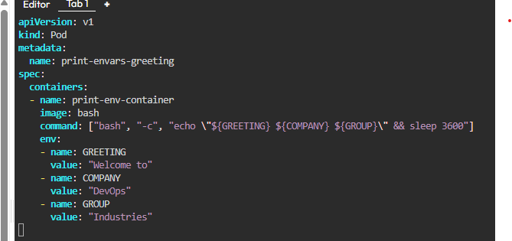

kubectl apply -f print-envars-greeting.yaml

kubectl logs -f print-envars-greeting

1. Where is the default kubeconfig file located in the current environment?

~/.kube/config

1. How many clusters are defined in the default kubeconfig file?15- What is the user configured in the current context?

kubectl config view

1. Create a Persistent Volume with the given specification.

Volume Name: pv-log

Storage: 100Mi

Access Modes: ReadWriteMany Host Path: /pv/log

1. Create a Persistent Volume Claim with the given specification.

Volume Name: claim-log-1

Storage Request: 50Mi

Access Modes: ReadWriteMany

1. Create a webapp pod to use the persistent volume claim as its storage.

Name: webapp

Image Name: nginx

Volume: PersistentVolumeClaim=claim-log-1

Volume Mount: /var/log/nginx

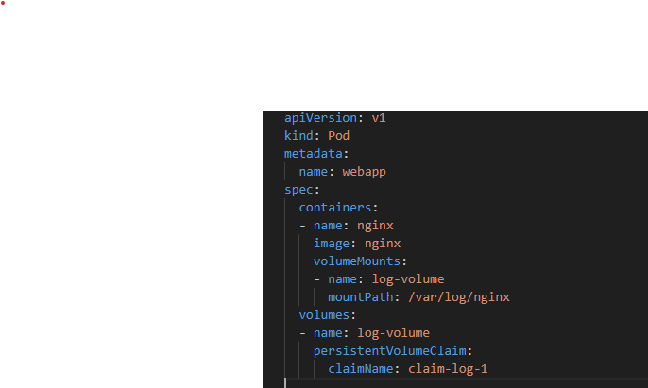 kubectl apply -f webapp-pvc.yaml